Yisho ukuthi lezizithombe zikusiphi isigaba zikusiphi isigaba ngazinye, ukiphe nseqalo segama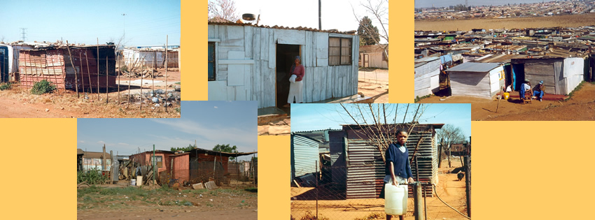
Figure 1 imikhukhu
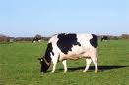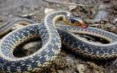
Figure 3 Inkomo Figure 2 inyoka
igama | isiqalo | isigaba
inkomo
Inyoka
imikhukhu

